**BCH-519**

**SURUCHI JAIKUMAR AHUJA**

**50170070**

Output for Meme :

Position is 1760

Motif is CGATCACTTG

Position is 952

Motif is GCACTTGAGC

Position is 5

Motif is CATGTTTAGT

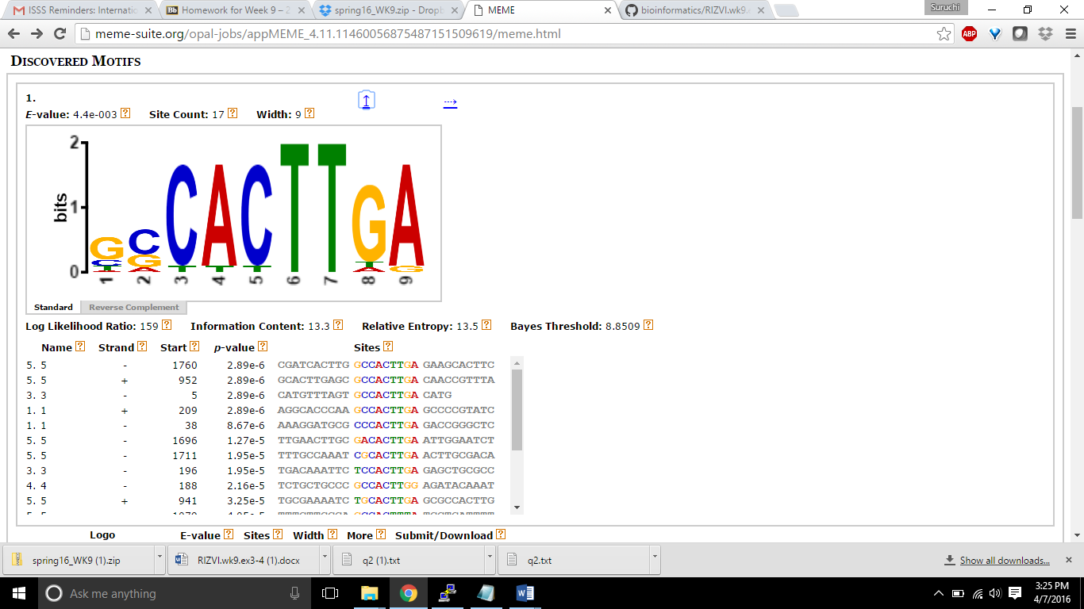

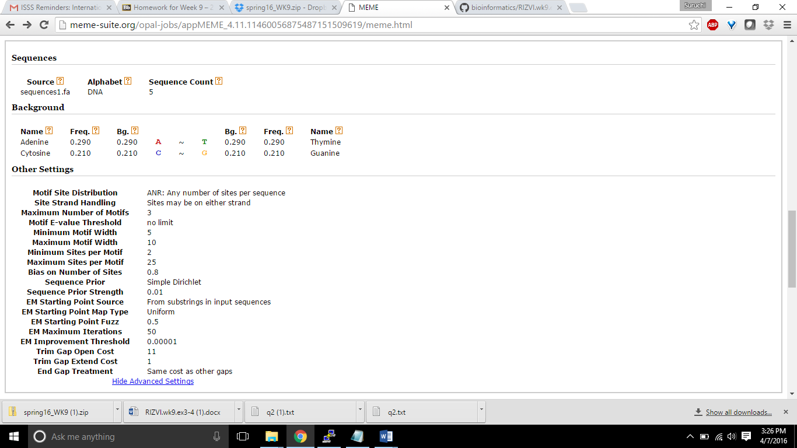

The output is quite similar. My program did a fairly good job in counting the k-mer as one of the k-mer found in the meme is same as the one in the program. The 3 forward strands had similar matches, while the reverse strands did not.